CHAPTER FOUR

4. DATA PRESENTATION, ANALYSIS AND INTERPRETATION

4.1 introduction
This chapter presents, analyzes, and interprets the data collected for the study titled "Impact of Financial Management System on Human Resource Utilization: A Case in Dire Dawa Municipality." The analysis is based on both primary and secondary sources of data. Primary data were obtained through structured questionnaires administered to 75 employees and interviews with managers and subordinates, while secondary data were gathered from official municipal documents, annual reports, and related literature.
The purpose of this chapter is to provide a clear and systematic presentation of the study’s findings in line with the research objectives. The data are organized into thematic sections: demographic characteristics of respondents, budgeting practices, budget approval, financial administration, and human resource utilization. For clarity, the results are displayed using tables, frequencies, and percentages, followed by interpretations that link the findings to the research problem and objectives.

4.2 Socio-demographic characteristics of respondents

4.2.1 Analysis for Demographic Characteristics of Respondents
Understanding the socio-demographic characteristics of respondents is essential in interpreting the findings of this study, as factors such as age, sex, education, and work experience can influence perceptions and practices related to financial management systems and human resource utilization. The distribution of respondents according to key demographic variables is presented below.
Table 1 Sex Ratio of Respondents
Sex | Respondents No. | %
Male | 30 | 40%
Female | 45 | 60%
Total | 75 | 100%
The results in Table 1 show that 40% (n=30) of respondents were male, while 60% (n=45) were female. This indicates that female employees constituted the majority of participants in this study, suggesting that women play a significant role in the workforce of Dire Dawa Municipality.
Table 2 Age Group of Respondents
Age Group | Respondents No. | %
19–25 | 26 | 35%
26–30 | 23 | 30%
31–36 | 15 | 20%
>37 | 11 | 15%
Total | 75 | 100%
As indicated in Table 2, the majority of respondents (35%, n=26) were in the 19–25 age category, followed by 30% (n=23) in the 26–30 category. This suggests that the municipality’s workforce is relatively young, which may have implications for adaptability and training needs in financial management practices.
Table 3 Marital Status of Respondents
Marital Status | Respondents No. | %
Married | 23 | 30%
Divorced | 11 | 15%
Single | 41 | 55%
Total | 75 | 100%
Table 3 shows that more than half of the respondents (55%, n=41) were single, while 30% (n=23) were married and 15% (n=11) were divorced. The predominance of single respondents could influence certain workplace engagement patterns, flexibility, and career mobility.
Table 4 Years of Experience
Years of Service | Respondents No. | %
1–5 | 23 | 30%
6–10 | 19 | 25%
11–15 | 11 | 15%
16–20 | 11 | 15%
21–25 | 8 | 10%
>26 | 4 | 5%
Total | 75 | 100%
According to Table 4, the largest group of respondents (30%, n=23) had 1–5 years of experience, followed by 25% (n=19) with 6–10 years. This suggests that a substantial proportion of employees are relatively new to the organization, which may affect institutional memory and the consistent application of financial management systems.
Table 5 Level of Education
Education Level | Respondents No. | %
Certificate | 8 | 10%
Diploma | 53 | 70%
Degree | 11 | 15%
Other | 4 | 5%
Total | 75 | 100%
Table 5 reveals that the majority of respondents (70%, n=53) hold a diploma qualification, followed by 15% (n=11) with a degree and 10% (n=8) with a certificate. This relatively high proportion of diploma holders suggests that while the workforce is moderately educated, opportunities for further academic advancement may enhance technical skills and financial management competency.
Figure 1 Working Section/Unit of Responsibility
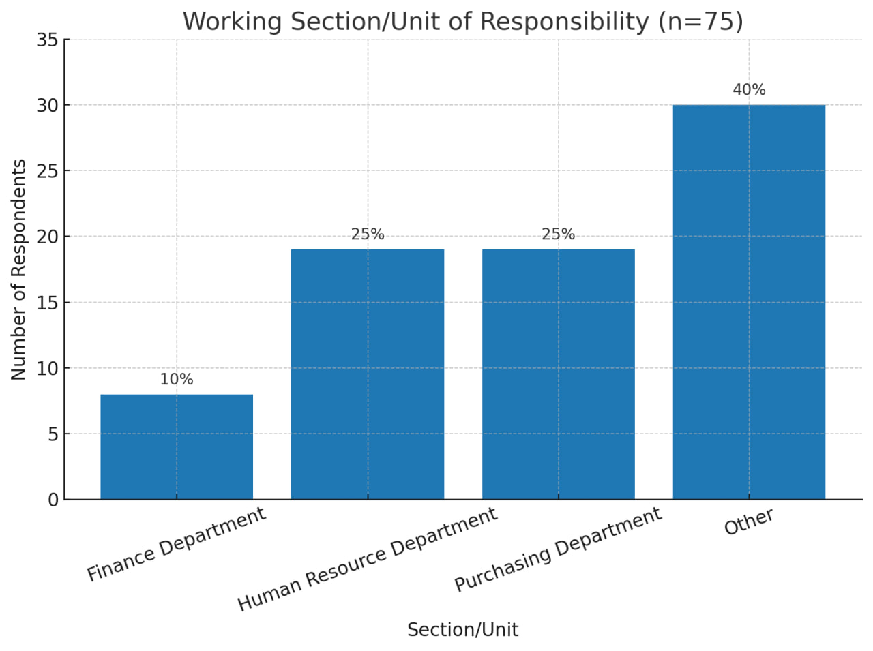
As presented in figure 1, the largest proportion of respondents (40%, n=30) worked in sections other than finance, human resources, or purchasing — such as investment, marketing, and inventory management. Human resource and purchasing departments each accounted for 25% of respondents, while the finance department had the smallest proportion (10%). This distribution reflects a broad representation of different functional areas within the municipality, ensuring diverse perspectives in the study findings.

4.3 Budgeting Practices
The budgeting practices within the municipality were assessed through various dimensions including the source of the budget, the presence of a budget plan, timing of budget preparation, participation in the budgeting process, and human resource capacity involved in budget preparation.
Table 6 The Source of Municipality Budget
Source | Respondents No. | %
Regional State | 34 | 45%
Federal Government | 8 | 10%
Society | 19 | 25%
NGOs | 11 | 15%
Other | 4 | 5%
Total | 75 | 100%
The findings indicate that the primary source of the municipality’s budget is the regional state, with 45% of respondents acknowledging this as the main funding origin. Other significant contributors include the society (25%), non-governmental organizations (NGOs) at 15%, and the federal government accounting for 10%. A minority (5%) indicated other unspecified sources. This distribution highlights a predominant reliance on regional government support, supplemented by community and external organizational contributions.
Table 7 Is There a Yearly Budget Plan?
Response | Respondents No. | %
Yes | 71 | 95%
I Don’t Know | 4 | 5%
Total | 75 | 100%
A substantial majority of respondents (95%) confirmed the existence of a formal yearly budget plan within the municipality, demonstrating a structured approach to financial planning. Only a small fraction (5%) was uncertain about the presence of such a plan. This suggests strong institutionalization of budget planning processes within the municipality.
Table 8 Period of Budget Preparation During the Year
Period | Respondents No. | %
Beginning of the Year | 45 | 60%
Middle of the Year | 11 | 15%
End of the Year | 11 | 15%
I Don’t Know | 8 | 10%
Total | 75 | 100%
Regarding the timing of budget preparation, 60% of participants reported that budget formulation takes place at the beginning of the fiscal year. A smaller proportion, 15%, indicated that preparation occurs in the middle or at the end of the year, respectively. About 10% were uncertain about the timing. The concentration of budgeting activities at the start of the year aligns with standard fiscal management practices, allowing for efficient allocation of resources for the upcoming period.
Table 9 Participants in Departmental Budget Preparation
Participants | Respondents No. | %
Budget Worker Only | 11 | 15%
Head of Department | 4 | 5%
Kebele Office | 4 | 5%
All | 56 | 75%
Total | 75 | 100%
Concerning participation in budget preparation, three-quarters (75%) of respondents indicated that all departments are involved in the budgeting process, reflecting a collaborative and inclusive approach. In contrast, smaller percentages reported that only budget workers (15%), heads of departments (5%), or kebele offices (5%) are involved exclusively. This broad participation may enhance the accuracy and comprehensiveness of budget development by incorporating diverse departmental insights.
Table 10 Human Resource Capacity for Budget Preparation
Capacity | Respondents No. | %
High | 19 | 25%
Medium | 23 | 30%
Low | 34 | 45%
Total | 75 | 100%
Assessment of the human resource capacity for budget preparation revealed that nearly half of the respondents (45%) perceive the capacity as low. Those rating capacity as medium constituted 30%, while only 25% regarded it as high. This indicates a potential challenge in adequately skilled personnel for effective budget planning and suggests the need for capacity-building interventions to strengthen the budgeting function within the municipality.

4.4 Budget Approval
This section presents findings on the timing and authority of budget approval in the municipality, as well as the use of budget codes and adherence to the budget cycle.
Table 11 When Does the Municipality Budget Get Approved?
Time of Approval | Respondents No. | %
As Soon as Prepared | 19 | 25%
Middle of the Year | 15 | 20%
End of the Year | 41 | 55%
Total | 75 | 100%
The data shows that the majority of respondents (55%) reported that the municipal budget is approved at the end of the year. A quarter (25%) indicated that approval happens immediately after budget preparation, while 20% stated that approval occurs in the middle of the year. The predominance of end-of-year budget approval suggests a formalized timeline aligning with fiscal year-end procedures, which may influence budget implementation and financial planning cycles.
Table 12 Municipality Budget is Approved By
Approving Body | Respondents No. | %
Management Only | 11 | 15%
City Council | 53 | 70%
Federal Government | 8 | 10%
Regional Parliament | 4 | 5%
Total | 75 | 100%
Regarding the approving authority, 70% of respondents identified the city council as the primary body responsible for budget approval. Smaller proportions indicated that management alone (15%), the federal government (10%), or the regional parliament (5%) hold approval authority. The central role of the city council underscores the municipality’s decentralized governance structure and highlights the importance of local legislative oversight in fiscal matters.
Table 13 Do You Use the Budget Code in Municipality?
Response | Respondents No. | %
Yes | 68 | 90%
I Don’t Know | 8 | 10%
Total | 75 | 100%
An overwhelming majority (90%) confirmed that budget codes are employed in the municipality’s financial management system, while 10% were unaware of their usage. The widespread use of budget codes reflects the municipality’s efforts to enhance transparency, accountability, and systematic tracking of financial resources.
Table 14 Do They Use the Budget Cycle Properly?
Response | Respondents No. | %
Yes | 49 | 65%
No | 8 | 10%
I Don’t Know | 19 | 25%
Total | 75 | 100%
Most respondents (65%) believe that the municipality properly follows the budget cycle, which includes formulation, approval, execution, and evaluation phases. However, 25% were uncertain about adherence, and 10% felt that the budget cycle is not properly used. This indicates room for improvement in communication and implementation of budget procedures to ensure consistent application of best practices.

4.5 Financial Administration
This section examines the practices related to financial administration within the municipality, focusing on receipt and expense balancing, the state of the financial management system, challenges faced, institutional attention to improvements, and timely reporting.
Table 15 How Many Times Does the Finance Department Practice Receipt and Expense Balancing?
Frequency | Respondents No. | %
Regularly | 56 | 75%
Sometimes | 15 | 20%
Not Practiced | 4 | 5%
Total | 75 | 100%
The majority of respondents (75%) reported that the finance department regularly practices balancing receipts and expenses, indicating a commitment to maintaining financial accuracy and accountability. A further 20% noted that balancing occurs sometimes, while only a small minority (5%) stated that this practice is not conducted. This suggests that routine financial reconciliation is largely embedded within the municipality’s administrative processes.
Table 16 Finance Management System in Municipality
Type | Respondents No. | %
Backward | 41 | 55%
Modern | 23 | 30%
I Don’t Know | 11 | 15%
Total | 75 | 100%
More than half of the respondents (55%) characterized the municipality’s financial management system as backward, whereas 30% considered it modern, and 15% were uncertain. This perception points to significant concerns regarding the adequacy and modernization of financial management tools and processes in the municipality.
Table 17 If Your Answer Above is “Backward,” What is the Reason?
Reason | Respondents No. | %
Lack of Skilled Manpower | 38 | 50%
Administrative Problem | 34 | 45%
I Don’t Know | 4 | 5%
Total | 75 | 100%
Among respondents who viewed the system as backward, the leading reason identified was a lack of skilled manpower, cited by 50%. Administrative problems were also significant, mentioned by 45%, while 5% were unsure. This highlights critical human resource and organizational challenges that impede the development and effective operation of the municipality’s financial systems.
Table 18 Municipality Attention to Improve Finance Accounting Administration System is
Attention Level | Respondents No. | %
High | 26 | 35%
Medium | 38 | 50%
Low | 11 | 15%
Total | 75 | 100%
Regarding efforts to improve the financial accounting administration system, half of the respondents (50%) rated the municipality’s attention as medium, 35% as high, and 15% as low. The predominance of medium-level attention suggests ongoing but perhaps insufficient focus on enhancing financial administrative capacity and systems.
Table 19 Do You Have Financial Reports on Time?
Response | Respondents No. | %
Yes | 56 | 75%
I Don’t Know | 19 | 25%
Total | 75 | 100%
A substantial proportion of respondents (75%) confirmed that financial reports are delivered on time, supporting effective decision-making and accountability. However, 25% were uncertain about the timeliness of reporting, which may indicate communication gaps or irregularities in reporting practices.

4.6 Human Resource Utilization
This section explores the leadership and planning related to human resource (HR) utilization within the municipality, focusing on management effectiveness, planning for HR functions, and the impact of financial management systems on HR practices.
Figure 2 Does the Manager Lead Properly for Financial Budget?
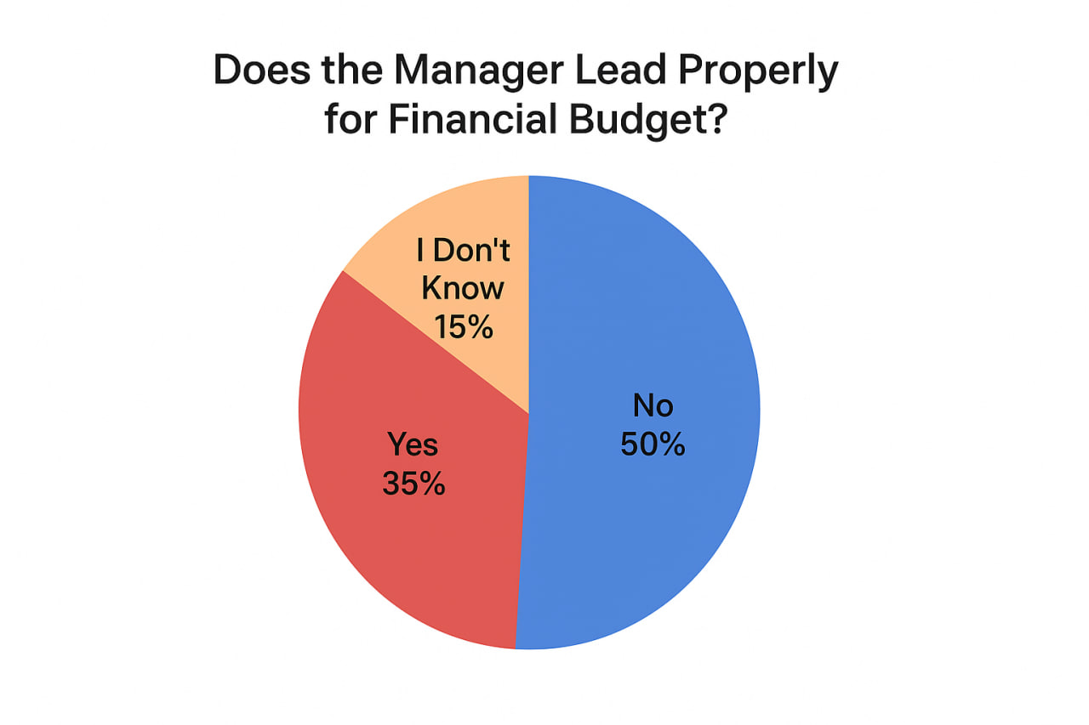
The findings reveal that only 35% of respondents believe managers lead the financial budget properly, while half (50%) perceive managerial leadership in this area as inadequate. The remaining 15% were uncertain. This indicates significant concerns regarding managerial effectiveness in guiding and overseeing budget-related activities, which may adversely affect overall organizational performance.
Table 20 : Is There Proper Plan for Recruitment, Selection, Job Design, Training, and Development?
Response | Respondents No. | %
Yes | 30 | 40%
No | 38 | 50%
I Don’t Know | 8 | 10%
Total | 75 | 100%
When asked about the presence of formal plans for recruitment, selection, job design, training, and development, 40% of respondents affirmed that such plans exist. However, half (50%) reported the absence of proper HR planning processes, with 10% uncertain. The lack of comprehensive HR planning underscores a potential gap in the municipality’s capacity to manage its workforce strategically.
Table 21 : If Your Answer Above is “No,” What is the Reason?
Reason | Respondents No. | %
Improper Financial Management System | 38 | 50%
Lack of Transparency and Accountability | 19 | 25%
Being Corrupted | 11 | 15%
All of the Above | 8 | 10%
Total | 75 | 100%
Among respondents indicating the absence of proper HR planning, the predominant reason (50%) was identified as an improper financial management system. Additionally, 25% attributed the deficiency to a lack of transparency and accountability, 15% cited corruption, and 10% acknowledged all these factors collectively. These challenges highlight systemic barriers within the municipality that hinder effective HR management and organizational governance.
Table 22 If There is Proper Financial Management System, Will HR Utilization Plan Run Properly?
Response | Respondents No. | %
Yes | 56 | 75%
No | 15 | 20%
I Don’t Think | 4 | 5%
Total | 75 | 100%
A significant majority (75%) agreed that implementing a proper financial management system would enable effective HR utilization planning, while 20% disagreed and 5% were uncertain. This suggests a strong perceived linkage between sound financial administration and successful human resource management, emphasizing the need for integrated improvements across financial and HR systems.

CHAPTER FIVE

5. SUMMARY, CONCLUSIONS AND RECOMMENDATIONS

5.1 Summary of Major Findings
This study explored the impact of the financial management system on human resource utilization at Dire Dawa Municipality. The data collected from 75 respondents revealed that the workforce is predominantly female, relatively young, and mostly holds diploma-level qualifications with limited years of experience. Employees represent various functional areas, ensuring a diverse set of perspectives. The municipality’s budget mainly comes from the regional state, with additional support from the community and NGOs. There is a formal yearly budget plan, mostly prepared at the beginning of the fiscal year, and broad participation from different departments in the budgeting process. However, nearly half of the respondents perceived the human resource capacity involved in budget preparation as low, signaling potential skill gaps.
Budget approval tends to occur at the end of the fiscal year, primarily overseen by the city council. Budget codes are widely used, and most respondents believe the municipality follows the budget cycle properly. Financial administration practices such as balancing receipts and expenses are regularly performed, but the financial management system is widely regarded as outdated, mainly due to a lack of skilled manpower and administrative challenges. Although efforts to improve the system exist, they are considered moderate.
Regarding human resource utilization, there is concern over inadequate managerial leadership in financial budgeting and the absence of proper HR planning, which is largely attributed to deficiencies in the financial management system. Most respondents agreed that a sound financial management system would significantly improve HR utilization planning.

5.2 Conclusions
The findings of this study indicate that the financial management system at Dire Dawa Municipality significantly influences human resource utilization but is hindered by several challenges. The current system is perceived as backward, with insufficient skilled personnel and administrative inefficiencies that negatively affect financial management practices. While budgeting processes are formalized and inclusive, limited capacity in budget preparation and delays in budget approval reduce the effectiveness of resource allocation. Managerial leadership in financial budgeting is seen as inadequate, contributing to poor strategic planning for human resources. The lack of comprehensive HR planning further limits the municipality’s ability to optimize its workforce, with these issues closely linked to shortcomings in the financial management system. There is a clear recognition that improvements in financial management would facilitate better planning and utilization of human resources. Therefore, integrated reforms in both financial and HR management systems are essential for enhancing organizational performance and ensuring sustainable development within the municipality.

5.3 Recommendations
To enhance the effectiveness of financial management and human resource utilization, the following recommendations are proposed:
- Strengthen Financial Management Capacity:
  - Invest in training and capacity-building programs to improve the skills of personnel involved in budgeting and financial administration.
  - Modernize financial management tools and systems to replace outdated processes and enhance efficiency.
- Enhance Managerial Leadership and Accountability:
  - Promote leadership development initiatives focused on financial stewardship and transparent budget management.
  - Establish clear accountability frameworks to ensure timely budget approvals and adherence to financial procedures.
- Improve HR Planning and Integration with Financial Systems:
  - Develop and implement comprehensive HR plans covering recruitment, selection, job design, training, and development aligned with financial capabilities.
  - Foster collaboration between finance and HR departments to ensure resource allocation supports workforce planning and utilization.
- Strengthen Communication and Awareness:
  - Increase awareness and understanding of budget cycles and financial policies among all employees to improve engagement and compliance.
  - Enhance transparency in budget processes to build trust and encourage participation.
- Regular Monitoring and Evaluation:
  - Establish mechanisms for regular monitoring and evaluation of financial and HR management practices to identify challenges early and implement corrective actions.

APPENDIX
DIRE DAWA UNIVERSITY
COLLEGE OF BUSINESS AND ECONOMICS
DEPARTMENT OF MANAGEMENT
Questionnaire for Employees
The aim of this questionnaire is to collect data for the research titled
“THE IMPACT OF FINANCIAL MANAGEMENT SYSTEM ON HUMAN RESOURCE UTILIZATION (A CASE IN DIRE DAWA MUNICIPALITY).”
The responses you provide are very valuable for the success of this study. We kindly request you to give accurate and honest answers.
Notice:
- You do not need to write your name.
- Mark ⎫ for questions that have alternatives.
Part One: Personal Data
Question | Options | Your Response
1. Sex | Male ☐ Female ☐
2. Age | 19–25 ☐ 26–30 ☐ 31–36 ☐ Above 36 ☐
3. Marital Status | Single ☐ Married ☐
4. Service Year | 1–5 ☐ 6–10 ☐ 11–15 ☐ 16–20 ☐ Above 25 ☐
5. Education Status | Certificate ☐ Diploma ☐ Degree ☐ Other ☐ | If other, specify:
6. Working Condition | Finance Dept Worker ☐ HR Worker ☐ Purchasing Dept Worker ☐

Part Two: About Source and Preparation of Budget
Question | Options | Your Response
1. Source of municipal budget | Regional State ☐ Federal Government ☐ Society ☐ NGO ☐ Other ☐ | If other, specify:
2. Is there a yearly budget plan? | Yes ☐ No ☐ I don’t know ☐
3. Period of budget preparation | Beginning of year ☐ Middle of year ☐ End of year ☐ I don’t know ☐
4. Participants in budget preparation | Budget worker only ☐ Head of Dept ☐ Kebele Office ☐ All ☐
5. Human resource capacity for budget preparation | High ☐ Medium ☐ Low ☐

Part Three: Budget Approval
Question | Options | Your Response
1. When is the municipal budget approved? | As soon as prepared ☐ Middle of year ☐ End of year ☐
2. Who approves the municipal budget? | Management only ☐ City Council ☐ Federal Gov’t ☐ Regional Gov’t ☐
3. Do you use the budget code? | Yes ☐ No ☐ I don’t know ☐
4. Is the budget cycle used properly? | Yes ☐ No ☐ I don’t know ☐

Part Four: About Financial Administration
Question | Options | Your Response
1. Frequency of balancing receipts & expenses | Regularly ☐ Sometimes ☐ Not practiced ☐
2. Financial management system status | Backward ☐ Modern ☐ I don’t know ☐
3. If backward, reason? | Lack of skilled manpower ☐ Administrative problem ☐ I don’t know ☐
4. Attention to improve financial system | High ☐ Medium ☐ Low ☐
5. Are financial reports on time? | Yes ☐ No ☐ I don’t know ☐

Part Five: Human Resource Utilization
Question | Options | Your Response
1. Does the manager lead properly for financial budget? | Yes ☐ No ☐ I don’t know ☐
2. Is there a proper plan for recruitment, selection, job design, training, development, and transfer? | Yes ☐ No ☐ I don’t know ☐

